Name__________________________

**Air Compression Dragsters**

Problem Statement: Given the **constraints**; brainstorm, research, and develop the fastest dragster in Seneca Middle School. Use your knowledge of **aerodynamics**, and **physics** to help you.

**Constraints:**

All cars must...

· Be 8 inches long (+ or - inch)

· Have wheels placed at equal distance

· Have a 2 inch deep air chamber

· Be full width of wood (3/4”) at axle hole locations

· Have 1/8” of wood around the air compression camber

Materials:

· 1 - 8” X 1-½” pine stock

· 4 - Wheels

· 2 - Axles

Tools & Machines to Utilize:

· Drill press

· Scroll saw

· Rasp

· File

· Sanding block & paper

Testing: Upon completion of your dragsters, all students will race their cars to test the success of their design. The car with the fastest time is the winner, good luck!

**Dragster Design Checkpoints **

□ Use the steps of the design process to come up with many solutions for your dragster. Must draw multi-view drawing (*use dragster template*).

□ Have your final design **approved** by the instructor before continuing.

□ Cut 8-inch pine stock.

□ Drill axles and air chamber.

□ Layout design on 8-inch pine stock.

□ Use the scroll saw to cut out the shape of your dragster.

□ Use a rasp and file to hone/shape the dragster body.

□ Sand and smooth dragster

□ Optional: Paint or color dragster

□ Assemble front and rear wheels and axles. Cut axles if necessary to improve wheel alignment.

□ Test wheel alignment

□ Apply lubrication where necessary.

□ Add fish-eye hook to car bottom

□ Race

|  |
| --- |
| Use the design process steps to guide you to your **solution.**  1. Identify the problem  2. Identify constraints (Limits to work in)  *a. Examples:* Time, Money, Materials, Skills, Client needs, Etc.  3. Research (what has worked or not work in the past and why)  4. Brainstorm  5. Select best solution and implement it  6. Evaluate, critique and analyze your work |

**Design the Dragster**

Directions: Design a dragster for the Seneca air compression racetrack. Use your knowledge of multi-view sketching to draw top and right side views of your dragster. Be creative and come up with as many ideas as possible. Use the example bellow to guide you through the process.

*⇒ Keep in mind all constraints.*

**⇒Keep in mind the location of the wheel axles and the air chamber when designing and cutting out your vehicle.**

-Knowledge of ***aerodynamics*** is important and should be used to design your dragsters. This will help reduce drag or air resistance that would otherwise slow down your car.

WIND TUNNEL TESTING- A tool used to study airflow over an object

|  |  |
| --- | --- |
|  | **Not Aerodynamic**  This is and example of a car that does not display good aerodynamics. The wind tunnel test shows a lot of rough areas. This car probably has a lot of drag and poor fuel efficiency. |
|  | **Aerodynamic**  In this example the wind tunnel test is showing a very smooth airflow. This car is much more aerodynamic than the first example. It probably experiences less wind resistance and better fuel efficiency. |

List 3 ways that aerodynamics affects the performance of a real car.

________________________________________________________________________________________________________________________________________________________________________________________________________________________________________________________________________________________________________________________________________

Which is most important when dealing with aerodynamics, size or shape?

a. Size

b. Shape

Why? ________________________________________________________________________________________________________________________________________________________________________________________________________________________________________________________________________

Air Dragster : Complete the 4 top & Side Sketches Below

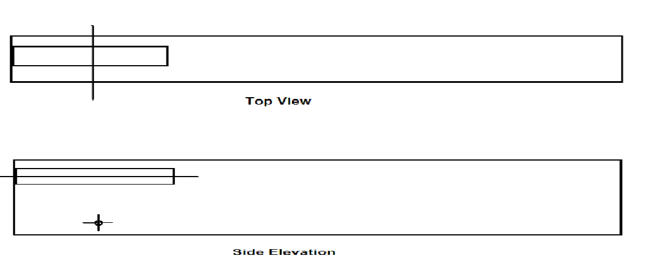

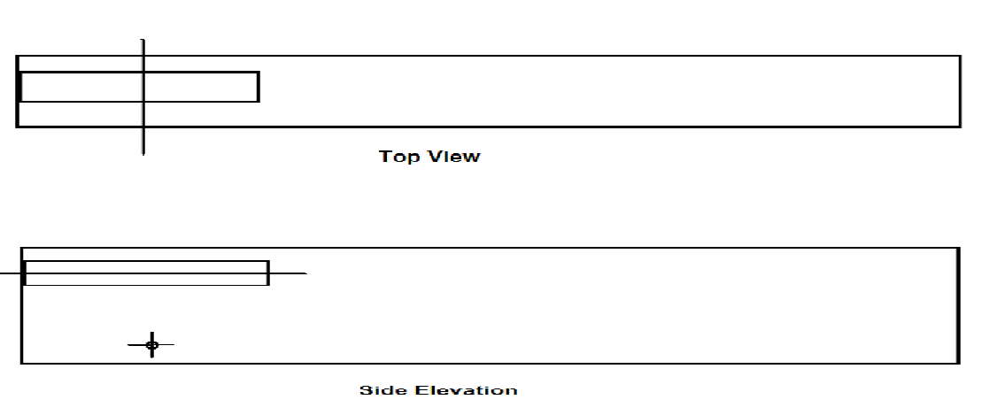

**Air Dragster Final Sketch Template**

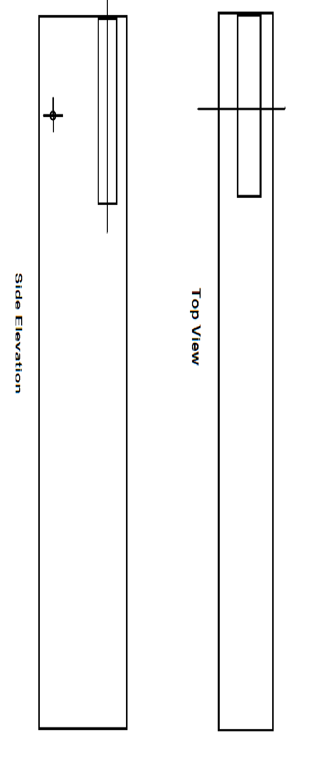

Newton’s 1st Law of motion – Also known as the law of inertia

-An object in motion will continue in motion unless acted on by another force.

-An object that is not moving will not move until a force is applied.

 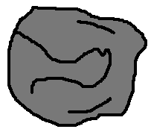

In this example the skateboard & person are moving together *(together they are an object in motion).* The skateboard suddenly hits a rock & is stopped *(the rock is an opposing force).* The person keeps moving because it has not been stopped by anything and continues moving forward. This is **Newton’s first law** at work.

This can be related to how frictional forces work on a dragsters wheel axle. When in motion, a wheel axle could spin forever. Friction *(an opposing force to motion)* wants to keep the axle still, thus slowing down the wheels until they stop.

 Think of a ball rolling a really sticky floor. It will roll a much shorter distance on a sticky floor than on a freshly cleaned and polished floor. The sticky stuff on the floor is like friction acting on a moving object.

Where do frictional forces act on your dragsters?

__________________________________________________________________

______________________________________________________________________________________________________________________________________________________________________________________________________

Can frictional forces be reduced on your car? Why or Why not?

________________________________________________________________________________________________________________________________________________________________________________________________________________________________________________________________________________________________________________________________________

Proper **Wheel Alignment** helps to keep a vehicle driving strait.

-This will help your dragsters reduce frictional forces and improve your overall speed and performance.

-The diagram to the right is an example of perfect wheel alignment.

[www.familycar.com/alignment](http://www.familycar.com/alignment)

|  |  |
| --- | --- |
|  | **Camber**  Camber is the leaning of a wheel from one side to the other. On your dragsters this may look like a wobbly wheel and will cause your car to drift left or right. It will also make your dragster slower on race day. |
|  | **Toe In**  Toe in is when the front end of your tires are closer together than the back end. This will increase friction on the track and cause your car to move much slower. |
|  | **Thrust Line**  Thrust line is the angle that your wheels point in relation to the center of your car. This causes your car to turn rather than move straight. |

How does wheel alignment affect the performance and speed of your car?

________________________________________________________________________________________________________________________________________________________________________________________________________________________________________________________________________________________________________________________________________

Newton’s 2nd Law of motion – According to Newton’s Second law, acceleration is produced when a force acts on a mass.

-The greater the mass *(weight)* of the object the greater the amount of force needed to accelerate that object.

**Baseball Pitcher with Baseball Baseball Pitcher with Bowling Ball**

The pitcher *(above)* is able to throw with enough ***Force*** to move a *baseball* 100 miles per hour. When he uses the same amount of ***Force*** to throw a *bowling ball*, it only moves at 10 miles per hour, and barely travels 10 feet.

This happens because the ***Mass*** of the *bowling* *ball* is so much greater than the ***Mass*** of the *baseball*. If a greater throwing force were added to the bowling ball, it would move faster and travel farther.

You can see how Force, Mass, and Acceleration are all related to each other. Newton created this equation to help us better understand this law.

*(Do not worry we will not be using this equation)*

**Force** = **Mass** X **Acceleration** (speed)

To relate this to our activity, a ***Force*** of 100 PSI *(pounds per square inch)* will be used to move our dragsters forward. How will the dragsters ***Mass*** *(weight)* affect its speed?

____________________________________________________________________________________________________________________________________________________________________________________________________________________________________________________________________________________________________________________________________________________________________________________________________________

**Vocabulary**

**Wheel Axles:**_______________________________________________

__________________________________________________________________________________________________________________

**AirChamber:** ______________________________________________

____________________________________________________________________________________________________________________

**Aerodynamics:** _____________________________________________

____________________________________________________________________________________________________________________

**Drag:** _____________________________________________________

____________________________________________________________________________________________________________________

**AirResistance:** _____________________________________________

____________________________________________________________________________________________________________________

**FuelEfficiency:** _____________________________________________

___________________________________________________________________________________________________________________

**WheelAlignment:** __________________________________________

___________________________________________________________________________________________________________________

**Air Dragster Final Sketch Template**

